***INVESTMENT PREDICTIONS***

**ARCHITECTURE**

Model training/validation workflow

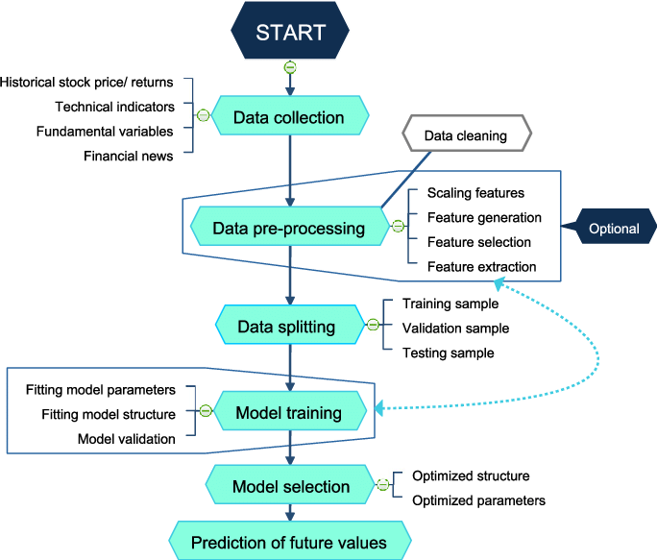

# User I/O workflow

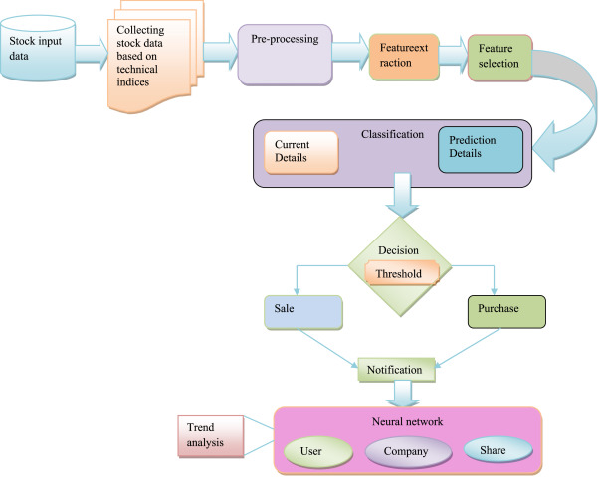

Data Representation Data need to be represented in some format before we can start analyzing it. In this section we will discuss how can we represent data for better interpretation.

